www.meezmarket.com or www.chefsantos.com
8320 Litchford Rd Suite 108 Raleigh NC 27615
Facebook: @meezmarket
Email: meezmarket@gmail.com
252-327-2445

Let us Meez for you.
(slang or short for Mise en place - a French culinary term meaning "putting things into place" or "everything in its place")

YOU ORDER
1. Order your meals from our chef’s weekly created menus.
WE PREPARE
2. Our team of culinary experts sources the finest ingredients & prepare the meals with you in mind.

WE DELIVER
3. The meals are delivered fresh right to your doorstep for a small fee, on pre-selected delivery days OR you can choose to pick up your meals at Meez Market and Catering.

YOU EAT
4. Our fully prepared meals are ready to heat-and-serve in less than 15 minutes. We Meez for you so you can enjoy guilt-free meals at your home, place of business, or on the go!

Please Check Our Online Store and Grocery Lists as well.

Meez Dips and Afternoon Delights

Chicken and Vegetable Pot Stickers
Lightly crisped in sesame oil and topped with Thai Chili Orange panzoo glaze $10.00 per serving

Butternut Squash and White Bean Hummus
Pureed chic peas, cooked butternut squash, white beans cooked in our chefs’ spices finished, roasted garlic and chilli paste served without house made sweet and Gluten Free smoky chips $10.00 for 16oz and $17.00 for a quart

Clams and Mussels Ina Italian Garlic Butter White Wine sauce
Carnalized onions, Italian salami, roasted garlic, clams and mussels with sundried tomatoes and fresh parsly in a garlic herb butter sauce $14.50per order served with garlic olive tepenade toast

Personal Charcuterie Boards
3 Chefs featured artisan meats, 3 cheeses, olive tapenade, strawberry jam, pineapple fig, and mango chutney, served with pickled cucumbers and peppers, lavish crackers, and candied pecans. All finished with our Meez infused flavored oils and vinegars.
$17.00 box (serves 2-3 people)
$22.00 box (serves 4-6 people)
$40.00 box (serves 8-10 people)

We also customize larger boards and specialty cheeses upon request.

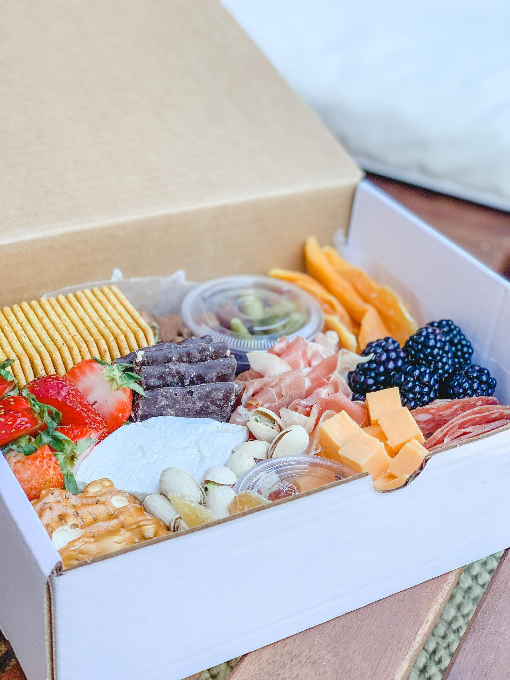

Rosemary Green Grape Chicken Salad
Cubed grilled chicken thighs, chopped celery, slices of green grapes, and rosemary in a lemon mayo
$8/pint and $16/quart

Buffalo Blue Cheese Hot Chicken Dip
Baked and topped with a hot blue cheese crema Served with house made blue cheese chips $9.50 per quart

Soups:

Seafood Florentine and Pasta Dumplings
Braised celery, carrots, thyme, sherry, corn, clams, salmon chunks and mussels in tomato seafood broth with Portuguese sausage chunks
$8.00/pint or $15.00/quart

White bean Chicken and Sausage Chili
slow braised chicken, white beans, chic peas, black eyed peas, celery, onions, sausage, carrots, and vegetables cooked down in chili spices served alongside The Raleigh Biscuit Company Biscuit $6.00/pint or $12/quart

Italian Northern Bean Butternut Squash
Pureed butternut squash, chicken broth, Italian sausage, northern beans, spinach, sweet peppers, carrots and corn with bay leaf and Italian spices
$6.00/pint and $11/quart

Salads

Butternut Squash Quinoa Kale Beet Salad
Roasted butternut squash, pickled red onions, cucumbers, cranberry raisins, quinoa, and kale in white peach vinaigrette finished with a blue cheese crema and candied pecans
$10.00 per order

Cucumber Feta Tomato Caprice Salad
Cherry tomatoes, baby mozzarella sliced, cucumbers, prickled red onions in a basil vinaigrette finished with olives and feta cheese cubes and balsamic glaze $9.00 per order

Add: Grilled Sweet and Smoky Chicken or Smoked House Pulled Pork for $3.00
Add: Grilled Citrus Salmon or Mahi Mahi for an additional $4.00
Add: Grilled Adobe Chipotle Steak Cubes $5.00

Assorted Desserts :

Gluten Free Brownie
Gluten free chocolate brownie topped with white chocolate mascarpone cream and fresh port wine marinated strawberries $4.00 per serving

House Made Dark Chocolate Cannoli
Stuffed dark chocolate covered Cannoli with a chocolate chip cannoli cream finished with powdered sugar 3 per order $4.50 per serving

Meez Caramel Chocolate Pie
Layers of peanut butter, salted caramel, rich custard in a flaky pie shell with fresh whipped cream and a light sauce
$5.00 per serving

Meez Weekly Menu Features

Gluten Free/Keto Options in RED (Upon request we can alter any of our menu items to your gluten free and or keto needs)

Keto: Pepper Jack Chicken Stuffed Peppers and Cabbage (topped with pepper jack cream sauce)
served in a light tomato barbecue sauce an mixed bean corn succotash 14.00 per serving

Keto: Mint Green Apple Rosemary Glazed Salmon Filet
Grilled squash, zucchini, red onions, and broccoli florets $13.50 per serving
Sub: chicken breasts, thighs, or Salmon for $11.50 per serving

Keto: Gluten Free Creamy Tomato Basil Chicken
Tender crispy pounded chicken cutlets basil, oregano crusted in a creamy tomato cream sauce grilled prosciutto wrapped asparagus bundles $14.00 per serving

Gluten Free Sesame Thai Chili Chicken Cutlets Sesame and Pot Stickers
Served over stir fry vegetables, fried rice, green onions, roasted sesame orange glazed green beans and carrots $13.50 per serving

Shrimp Lingui and Clams a la Penne
Sauteed NC shrimp, little neck clams, onions, roasted garlic, olives and Portuguese sausage in a lemon pepper garlic white wine chicken broth ready to pour over asiago parmesan basil penne pasta served with garlic olive tapenade toast $14.00 per serving

Bourbon Molasses Beef Tips
bourbon molasses marinated beef tips, wild mushrooms, roasted corn and French green beans over cinnamon sweet potato mash all topped with a light orange pepper bourbon glaze $18.00 per serving Sub: Chicken for $13.00 per serving

Pork Empanadas
Pulled smoky barbecue pork, beans, cheese, and Spanish spices served over cilantro yellow rice, cucumber tomatillo cabbage salad and dipping sauce $12.50 per serving

Rosemary Creamy Chicken Pot Pie
Chunks of chicken, peas, carrots in rich creamy chicken broth baked in a light 6-inch pastry tartlets topped with pastry baked and served with braised carrots and broccoli florets $13.00

Our Meez Market Groceries and Provisions

Steaks and Meats:
- Hand Cut 12 Oz Certified Angus Butchers Block Ribeye $17.00 per steak
- Thick Cut Molasses Bourbon Marinated Ribeye Steaks 10-12oz ready to finish on your own grill $18.00 per steak
- 8 oz Certified Angus Hand Center Cut Filet Mignon Steaks $18.00 per steak
- 8 oz Certified Angus Hand Center Cut Filet Mignon Steaks Rubbed in our Espresso Cracked Pepper Rub $19.00 per steak

Poultry/Pork/Other:
- Chicken Thighs Boneless Organic and Trimmed Clean from Fat $3.50/lb
- Chicken Thighs Boneless Organic Sweet and Smoky Barbecue marinated ready to grill $3.75/lb
- Chef Santos In House Made Fresh Portuguese Smoked Cured Sausage $7.00/lb

Seafood:
- NC Caught Mahi Steaks $14/lb 12-14 oz steaks bone in
- NC Mahi Mahi Vacuum packed frozen 4 oz portions $9.00/lb
- Fresh Wild Caught Faro Island Salmon filets $16.50/lb
- Sushi Grade Ahi Tuna Fresh 6oz Vacuum Sealed $13/lb
- NC Wahoo $12.00 a lb ( 6oz steaks)

Frozen/Fresh Artisanal Pasta/Vegan
- Black Bean Burgers (made in house, contains assorted beans, corn, carrots, celery, onions) Ready to cook $3.50 each
- Potato Three Cheese Perogies $9.00/lb
- Cheese Filled Tortellini Frozen $6.00/lb
- 1 pound Gnocchi Pasta ready to cook $9/bag

Produce and Provisions:
- Fresh Organic Green Cabbage $4.00/head (large heads)
- Jumbo Sweet Potato 3 Eagles Farm $2.70/lb
- Yellow Squash Fresh $2.75/lb
- Zucchini Fresh $2.75/lb
- Fresh Whole Carrots $3/lb
- Fresh Tomatoes Whole Market Price
- Red onions Market Price, Brussel Sprouts and Broccolini or Wild Mushrooms Market price

Cleaning Supplies

- CLOREX BLEACH WIPES $11 PER CONTAINER
- Concentrated Commercial Bleach $3.00 a gallon
- Sanitizer Tablets for Hand soap sinks and dishes $11 jar 150 tablets
- Food Contact Safe Spray Sanitizer $10 per Spray Bottle.
- Large and XL powder free Gloves $12 a box of 100
- Medium Gloves Powder Free $12 a box
- Powdered Gloves Medium, Large and XL $12 a box of 100
- Garbage bags and household goods are available in bulk, and I can order through our distributor, and I can get you pricing on any household items if needed or in a shortage
- Cleaning Supplies etc…Can be ordered in bulk as well.

Infused Oils and Vinegars
(Cook with some of Chef Santos’ infused oils and vinegars)

- White Peach Vinegar (hints of apricot, apple, and orange peel: great in salads, desserts, and pork)
- White Ginger Honey Balsamic Vinegar (great on desserts, salads, seafood, pork, chicken, and in salads)
- Smoked Dark Balsamic Vinegar (great on salads, any grilled meats, appetizers, and vegetables)
- Dark Black Cherry Balsamic Vinegar (great with chicken, trout, turkey, salmon, on salads or cheese boards)
- Blood Orange Infused Olive Oil (great on salads, chicken, fish, and on desserts)

All of our oils and vinegars are available in large bottles for $13.00/bottle.
These oils and vinegars are very concentrated and go a long way.
Get suggestions on recipes from Chef Santos, available upon purchase.

Please place orders via email @ meezmarket@gmail.com

Meals can be delivered once a week on the day of your choice for a $8.00 charge (within a 8-10 miles range from our kitchen. Price vary if we have to travel farther then outside our area or you can arrange a customized pick-up time at Meez Market and Catering.

The Meez Market team looks forward to being a part of your weekly meal plan!

Please keep up with us on/Like and Follow Us:
Facebook @meezmarket
Instagram: @#letsmeez

