www.meezmarket.com or www.chefsantos.com
8320 Litchford Rd Suite 108 Raleigh NC 27615
Facebook: @meezmarket
Email: meezmarket@gmail.com
252-327-2445
Let us Meez for you.
(slang or short for Mise en place - a French culinary term meaning "putting things into place" or "everything in its place")

YOU ORDER
1. Order your meals from our chef’s weekly created menus.
WE PREPARE
2. Our team of culinary experts sources the finest ingredients & prepare the meals with you in mind.

WE DELIVER
3. The meals are delivered fresh right to your doorstep on pre-selected delivery days for a small fee, OR you can choose to pick up your meals at Meez Market and Catering.

YOU EAT
4. Our fully prepared meals are ready to heat-and-serve in less than 15 minutes. We Meez for you so you can enjoy guilt-free meals at your home, place of business, or on the go! Please Check Our Inline Store and Grocery Lists as well.

Meez Dips and Afternoon Delights

Hand stuffed Pulled Chicken and Cabbage Dumplings
Pulled chicken, and ground poek tossed in a Asian spices, pickled ginger, cabbage and water chestnuts, scallions and carrots in egg roll dumplings and pan fried served with a papaya mango chutney and panzoo glaze (4 per order) $11.00 per order

Seared Ahi Tuna Rolled Summer Roll Stuffed with Strawberry
pepperd seared Ahi tuna sliced thin stuffed with strawberry, cucumber slaw, rolled in a rice papper wrapper served along side panzoo glaze, pickled ginger and wasabi $13.00 per served

Smoked Salmon Trout dip
Smoked salmon, smoked trout, cream cheese, chives and crab baked with three cheese served with old bay chips) $9.00 per serving

Smoked Gouda Crab Dip
NC lump and claw meat mixed in array of smoked cheeses and Cajun spices
Served with old bay seasoned in house made chips. $8.00 per pint and $16 a quart

Personal Charcuterie Boards
3 Chefs featured artisan meats, 3 cheeses, olive tapenade, strawberry jam, and pineapple fig and mango chutney served with pickled cucumbers and peppers, lavish crackers and candied pecans all finished with our Meez Infused flavored oils and vinegars.
$18.00per box (serves 2-3ppl)
$27.00 serves 4-6ppl
$46.00 serves 8-10ppl We also customize larger boards and specialty cheese upon requests. 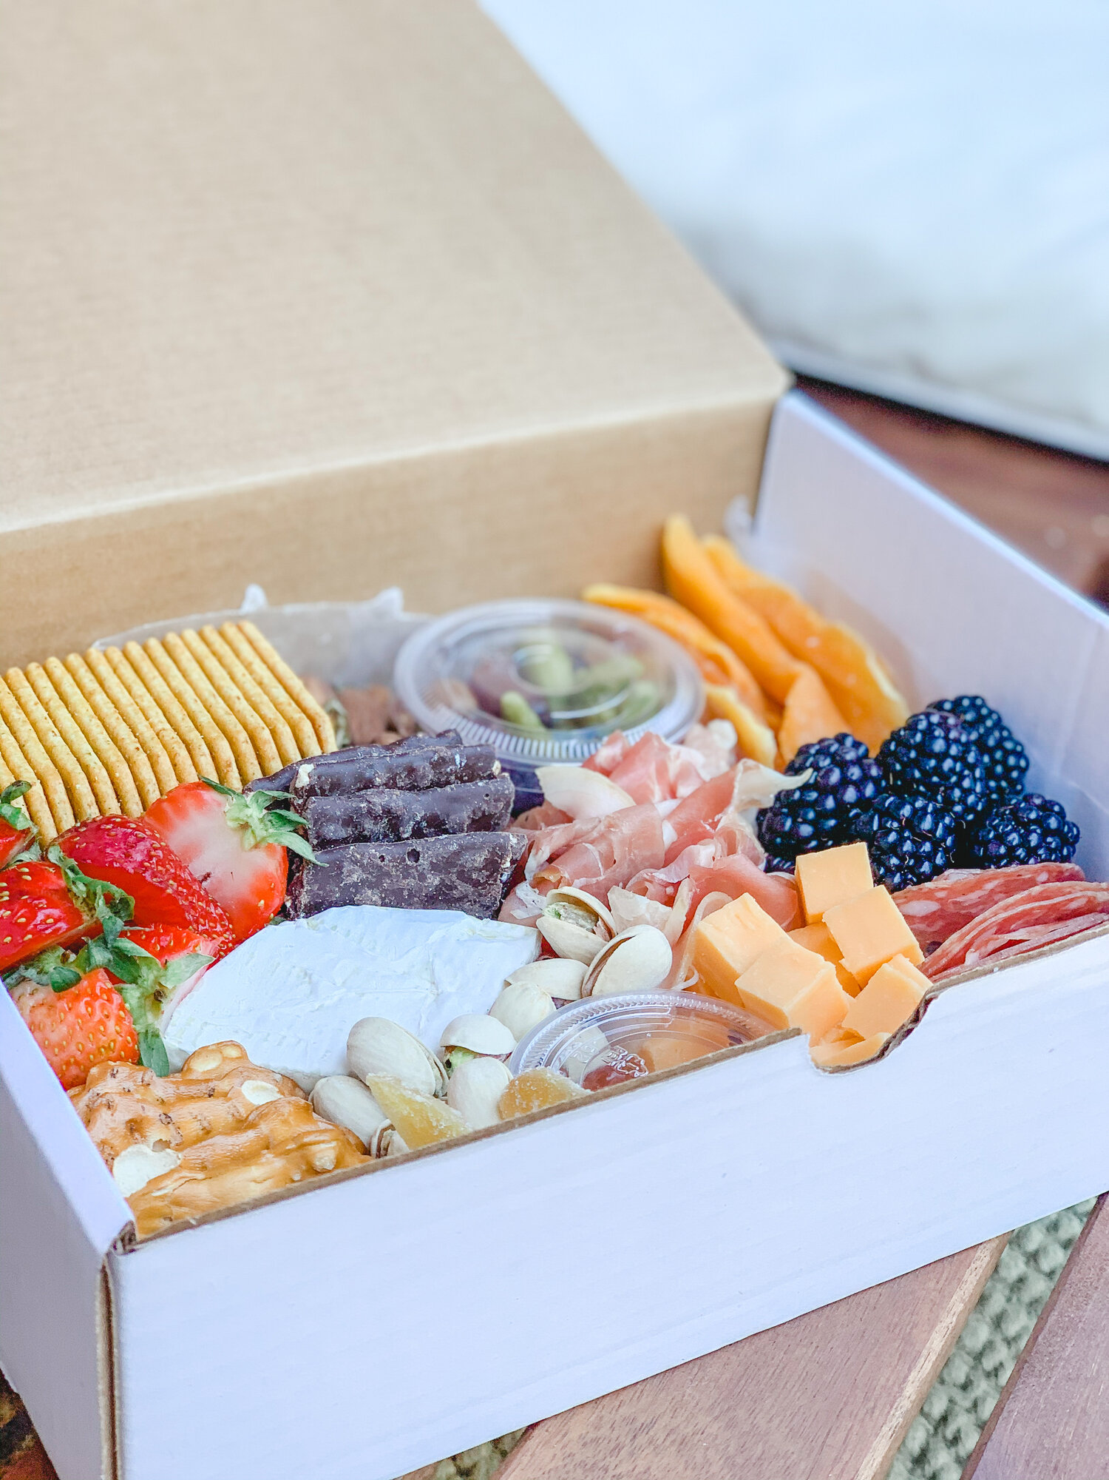

Rosemary Green Grape Chicken Salad
Grilled chicken thighs, chopped small celery, green grapes and rosemary in a lemon mayo
$8 a pint and $16 a quart

Meez Buffalo Chicken Jalapeno Pimento Cheese
Chopped japaeno, piri piri spices, sharp chedder, green onions, roasted peppers cream cheese and a light Kens mayo finished with a hint of citru served sweet and smoky chips $7 pint and $14 a quart

Soups:

Butturnut Squash and Kale Soup
Cooked butturnut squash, pumkin puree, celry, onions slow cooked and coconut cream ,dried ranberries, and roasted fennel 5.00 a pint and $11.00 per quart

Chicken Shrimp Chedder Florentine Potato Soup
Slow braised chicken, cleery, carrots, onion in a hearty creamy chicken broth finished with mixed cheeses and yukon gold potato chunks
$6 a pint and $11 a quart

Wild Mushroom Black Truffle Soup
Slow cooked medlay of portabello mushrooms cremini, mushrooms, swimming in a creamy garlic rosmeary broth finished with black truffle salted pyster mushrooms and roasted peppers
$6.50 a pint and $11 a quart

Salads

Roasted Squash and Brococli Salad
Super kale mixed greens, cucumbers, pickled onions, roasted acorn and butturnut squash, and ligtly blached brocoli in raspberry mint vinagertte topped candied pecns and got cheese crumbles $9.00 Each

Baby Mozzerela Tomato Olive Salad
Italian Artisan sliced meats, olives, sundried tomatoes, cherry tomatoes, pickled red onions, cucumbers and baby mozzerela finished with our smoked honey mustard baslamic dressing
$9.00 each
Add Grilled Sweet and Smoky Chicken Cubes: for $3.00 per serving
Add: Grilled Citrus Salmon for an additional $4.00
Add: Grilled Adobe Chipotle Steak Cubes $5.00 per serving

Assorted Desserts

Warm Bread Pudding Squares
finished with strawberry port wine glaze
$4.50 per serving

Brownie Chocolate Peanut Butter Thunder
Layered rich Godiva brownies, creamed white chocolate mousse, butterfingers crumbles and Butterfinger crumbs topped with a rich whipped cream and finished with rich cholate sauce garnished with a cherries $5.00 per slice

Strawberry Mint Custard Tarlets
3 inch pastry tarlets layred with a light pastry cream topped with mint blueberry glaze and fresh whipped topping $5.00 per serving ( 2 per serving)

Milanao Cookie Tiramasu
layred milano cooki and lady fingers in amerreto coffee liqour, cinamon marscapone cream and cholate raspberry ganache topping $5.50 each

Apple Peach Streusel
Stuffed with caramelized apples, peaches, brown sugar and white chocolate sauce in layered in phyllo pastry sheets rolled and served fresh whip cream and berries

Meez Weekly Menu Features

Gluten / Keto Free Options in RED (If requested we can Alter any of our Items to your gluten and or keto needs)

Keto: Grilled Mango Panzoo Glazed Salmon
Grilled mango soy glazed salmon topped with mango mint chutney, sauteed bok choy, sweet peppers, onions, cauliflower rice. $14.00 each

Keto: Rosemary Lemon Pepper Grilled Tuna
Ahi Tuna steak grilled in a rosemary lemon orange glazed, roasted brussles tossed in a smokey baslamic glaze, served with stone fruit herbed quinoa $16.00 each
Sub: Chicken for Tuna $11 per serving

Keto: Gluten Free Floured Chicken or Pork Shnitzel
Toppred with wilf mushroom bacon ragout, seasoned broccoli, grilled sweet peppers and onions $13.00 each

Keto: Shrimp and Crab Cake Creamy Tomato Rose
Sauteed garlic and sundried tomato shrimp, onions, artichokes in a light creamy tomato rose serve over brocoli and a oven baked gluten free oven baed crab cake and garlic green beans $17.00 per serving

Pork Osso Buco
Slow Braised Pork Shank falling off the bone )
Served in a wine demi with mushrooms, celry, carrots, smoked gouda mash potatoes and augratin creamed spinach and corn $19.00 per serving

Grilled Sweet and Smoky Whahoo Bites
roasted buttrunut squash and parsnip puree, roasted root vegetbles all topped with light champaghne barbacue shallot sauce and sauteed bok choy $16.00 Per Serving

Classic German Sauer Braten Pot Roast
Slow cooked burgundy braised demi bacon potatoe cruquettes, briased carrots and pickled braised cabbage $17.00 per serving

Portuguse Seafood Paella
Slow cooked onions, garlic, olives, jumbo shrimp, white grouper, clams, mussels in white wine tomato broth slow cooked in our house made smoked portuguese safron rice, green peas and carrots finished with fresh parsly
$20.00 per serving
Sub Chicken for Seafood for : $16.00 per serving

Pan Seared Chicken Carbanara
Pan seared chicken cutlets in a Italian bacon white gravy nestled in a fresh pasta dumplings, asiago cheese, with roasted corn, sundried tomatoes and garlic green beans $13 per serving

Chimi Churi Hanger Steak
Marinated and lightly charred on grill for you to finish at home, served over spanish yellow rice, chitpotle buttuer beans, grilled shrimp and spanish tomato white and purple cabbage cilantro salad
$17.50 per serving

Our Meez Market Groceries and Provisions
- Steaks and Meats
- Hand Cut 12 Oz Certified Angus Butchers Block Ribeye $17.00 per steak
- Thick Cut Molasses Bourbon Marinated Ribeye Steaks 10-12oz ready to finish on your own grill $17.00 per steak
- 8 oz Certified Angus Hand Center Cut Filet Mighnon Steaks $18.00 per steak
- 8 oz Certified Angus Hand Center Cut Filet Mighnon Steaks Rubbed in our Espresso Cracked Pepper Rub $18.50 per steak

- Poultry / Pork / Other
- Chicken Thighs Boneless Organic and Trimmed Cleaned Fat $3.75 a lb
- Chicken Thighs Boneless Organic Sweet and Smoky Barbecue marinated ready to grill $4.75 a lb
- Whole Pork but boneless $2.25 a lb
- Chef Santos In House Made Fresh Portuguese Smoked Cured Sausage $7.00 lb

- Seafood
- Wahoo Steaks $14 a lb 12-14 oz steaks bone in
- Chilean Seabass Sea Bass $17.50 a lb
- 5 oz in house Handmade Crab Cakes Ready to cook $6.50 a crab cake ready to cook
- NC Mahi Mahi Vacuum packed frozen 4 oz portions $9.00 a lb
- Fresh Wild Caught Faro Island Salmon filets $16.50 lb
- Sushi Grade Ahi Tuna Fresh 6opz Vacuum Sealed $13lb
- Fresh Claw Meat Claw Meat $16 lb
- Fresh Lump / Backfin / Claw Mix $18lb
- Fresh Lump Crab Meat $20 a lb

Frozen / Fresh Artisanal Pasta / Vegan
- Black Bean Burgers (made in house, contains assorted beans, corn, carrots, celery, onions) Ready to cook $3.50 each
- Potato Three Cheese Perogies $9.00 a lb
- Cheese Filled Tortellini Frozen $6.00 a lb
- 1 lb Gnocchi Pasta ready to cook $9 a bag

- Produce and Provisions
- Oysters Mushrooms $10 a lb Fresh
- Fresh Organic Green Cabbage $4.00 a head (large heads)
- Jumbo Sweet Potato 3 Eagles Farm $2.50 lb
- Yellow Squash Fresh $2.75lb
- Zucchini Fresh $2.75 lb
- Fresh Whole Carrots $3 lb
- Fresh Tomatoes Whole Mrkt Price
- Red onions Mrkt Price, Brussels Sprouts and Broccolini or Wild Mushrooms Market price.

- Cleaning Supplies
- CLOREX BLEACH WIPES $11 PER CONTAINER
- Concentrated Commercial. Bleach $3.00 a gallon
- Hand Soap by the Gallon $20 a Gallon
- Hand Gel market price $43 per Gallon
- Sanitizer Tablets for Hand soap sinks and dishes $11 jar 150 tablets
- Food Contact Safe Spray Sanitizer $10 per Spray Bottle.
- Large and XL powder free Gloves $13 a box of 100
- Medium Gloves Powder Free $13 a box
- Powdered Gloves Medium, Large and XL $13 a box of 100
- Garbage bags, household goods are available in bulk and I can order through our distributor companies and I can get you pricing on any of household items if needed or a shortage of.
- Cleaning Supplies etc.. Can be ordered in bulk as well.

- Infused Oils and Vinegars (cook with some of Chef Santos infused oils and vinegars)
- White Peach Vinager (hints of apricot, apple, and orange peel great in salads, desserts and pork)
- White Ginger Honey Balsamic Vinager (great on desserts, salads, seafood, pork, chicken in salads)
- Smoked Dark Balsamic Vinager (great on salads, any grilled meats, appetizers, vegetables)
- Dark Black Cherry Balsamic Vinager (great with chicken, trout, turkey, salmon or on salads or cheese boards)
- Blood Orange Infused Olive Oil (great on salads, chicken, fish and on desserts)

- All of our oils and vinegars are available in large bottles for $13.00 per large bottle. These oils and vinegars are very concentrated and go a long way. Get suggestions on Recipes from Chef Santos available upon purchase
Please place orders via email @ meezmarket@gmail.com Meals can be delivered once a week on the day of your choice for a $5.00 charge or you can arrange a customized pick-up time at Meez Market and Catering.
The Meez Market team looks forward to being a part of your weekly meal plan! Please keep up with us on Facebook @meezmarket
Instagram: @#letsmeez

