www.meezmarket.com or www.chefsantos.com
8320 Litchford Rd Suite 108 Raleigh NC 27615
Facebook: @meezmarket
Email: meezmarket@gmail.com
252-327-2445

Let us Meez for you.
(slang or short for Mise en place - a French culinary term meaning "putting things into place" or "everything in its place")

YOU ORDER
1. Order your meals from our chef’s weekly created menus.
WE PREPARE
2. Our team of culinary experts sources the finest ingredients & prepare the meals with you in mind.

WE DELIVER
3. The meals are delivered fresh right to your doorstep for a small fee, on pre-selected delivery days OR you can choose to pick up your meals at Meez Market and Catering.

YOU EAT
4. Our fully prepared meals are ready to heat-and-serve in less than 15 minutes. We Meez for you so you can enjoy guilt-free meals at your home, place of business, or on the go!

Please Check Our Online Store and Grocery Lists as well.

Meez Dips and Afternoon Delights

Pulled Pork BBQ Wontons
Season slow roasted pulled pork, sauteed with caramelized onions, mixed shredded cheeses, herbs, wrapped in egg roll wrappers, and fried with house smokey BBQ Sauce (4 per order) $11.00 per order

Blackened Mahi Mahi Bites
Topped with a mango grape cilantro chutney and citrus sauce, served with a side of cucumber Asian Slaw
$9.00 per order

Coconut Fried Shrimp
Topped with a mango pineapple cilantro chutney and citrus slaw $12.00 per order

Smoked Gouda Crab Dip
NC lump and claw meat mixed in an array of smoked cheeses and Cajun spices.
Served with in house made Old Bay seasoned chips. $9.00/pint or $16/quart

Personal Charcuterie Boards
3 Chefs featured artisan meats, 3 cheeses, olive tapenade, strawberry jam, and pineapple fig and mango chutney served with pickled cucumbers and peppers, lavish crackers, and candied pecans, all finished with our Meez Infused flavored oils and vinegars.

$17.00 box (serves 2-3 people)
$25.00 box (serves 4-6 people)
$44.00 box (serves 8-10 people)

We also customize larger boards and specialty cheeses upon request.

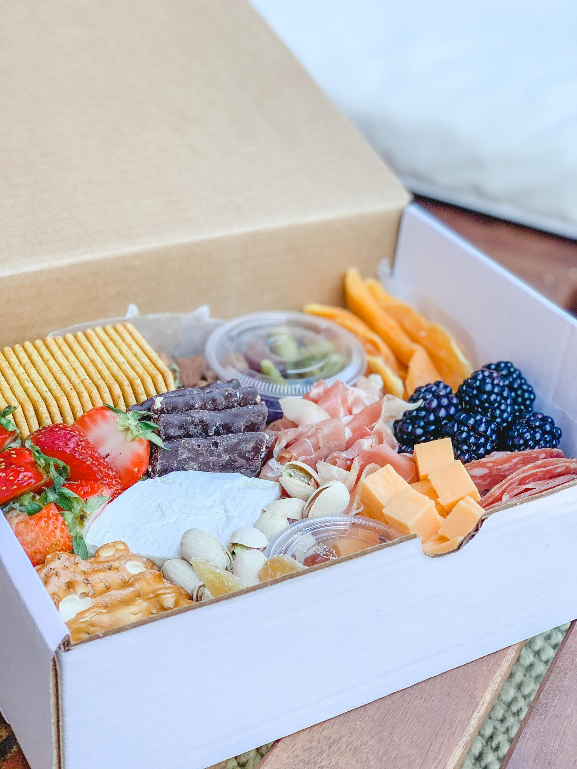

Rosemary Green Grape Chicken Salad
Cubed grilled chicken thighs, chopped celery, slices of green grapes, and rosemary in a lemon mayo
$8/pint and $16/quart

Jalapeno Pineapple Pimento Cheese Spread
Our sweet and smoky chopped peppers and mixed shredded sharp cheddar cream cheese, finished with fresh green onions served with house made chips $7.00/pint or $13.00/quart

Soups:

Chicken Mac and Cheese Soup
Slow cooked pulled chicken, celery, carrots, onions in a rich chicken broth finished with elbow mac and cheese pasta dumplings $5.00/pint or $11.00/quart

Shrimp Corn Chowder
Slow cooked sweet onions, corn, bacon and Portuguese sausage and NC shrimp, swimming in a potato sherry cream broth $6.00/pint or $12/quart

Wild Mushroom Black Truffle Potato Soup
Slow cooked medley of portobello mushrooms, cremini mushrooms, swimming in a creamy garlic rosemary broth finished with black truffle salted fingerling potatoes
$6.00/pint and $11/quart

Salads

Watermelon Grilled Cucumber Mint Salad
Super kale mixed greens, cucumbers, pickled onions, watermelon, roasted acorn, cranberry raisins, candied pecans, and goat cheese crumbles, finished with a mint raspberry yogurt citrus vinaigrette $9.00 per order

Baby Mozzarella Tomato Olive Salad
Italian Artisan sliced meats, olives, sundried tomatoes, cherry tomatoes, pickled red onions, cucumbers, and baby mozzarella, finished with our smoked honey mustard balsamic dressing $9.00 per order

Add Grilled Sweet and Smoky Chicken Cubes for $3.00
Add: Grilled Citrus Salmon or Mahi Mahi for an additional $4.00
Add: Grilled Adobe Chipotle Steak Cubes $5.00

Assorted Desserts:

Warm Bread Pudding Squares
Finished with strawberry port wine glaze $4.00 per serving

Brownie Chocolate Peanut Butter Thunder
Layered rich Godiva brownies, creamed white chocolate mousse, Butterfinger crumbles topped with a rich whipped cream, and finished with rich chocolate sauce, garnished with cherries $5.00 per serving

Apple Peach Streusel
Stuffed with caramelized apples, peaches, brown sugar, and white chocolate sauce, layered in rolled phyllo pastry sheets, served with fresh whip cream and berries $4.00 per serving

Graham Cracker Crusted Berry Lemon Bars
House made Lemon bars with graham cracker crust, topped with berry glaze, shortbread crust,
finished with vanilla cream icing $5.00

Meez Weekly Menu Features

Gluten Free/Keto Options in RED (Upon request we can alter any of our menu items to your gluten free and or keto needs)

Keto: Sesame Almond Crusted Mahi Mahi
Topped with a roasted pepper cream sauce, grilled squash, and zucchini $14.00 per serving

Keto: Rosemary Bing Cherry Pepper Grilled Salmon Filet
Salmon filet grilled in a rosemary Bing cherry glaze, roasted Brussel sprouts, with grilled zucchini, squash, and roasted peppers $14.00 per serving Sub: Chicken for Salmon $11 per serving

Keto: Barbeque Grilled Hanger Steak
Served over ginger pepper spiced vegetables in a sweet pepper Asian white sauce and sesame glazed broccoli spears $17.00 per serving

Gluten Free: Stuffed Italian Sausage Rolled Gluten Free Pasta
Sundried tomatoes, fresh basil, olive tapenade, prosciutto, Italian sausage, artichoke hearts, spinach ricotta, rolled in gluten free pasta rolls, baked in a classic garlic tomato vodka sauce, grilled balsamic glazed squash, and zucchini $14.00 per serving

Veggie Beef Lasagna
Seasoned grilled veggies and meat sauce, ricotta, parmesan, mozzarella cheeses layered, baked, and finished with a hardy vodka sauce and asiago cheese. Paired with a side of mixed green salad and white peach herb vinaigrette. $13 per serving

Braised Beef Short Rib
Served over asiago creamed carbonara noodles, roasted cherry pepper Brussel sprouts $17.00 per serving

Asian Beef Bowl
Shaved soy ginger glazed beef tips, carrots, Brussel sprouts, green onions, mixed cabbage, squash, zucchini, mixed peppers in an orange teriyaki glaze finished with sesame seeds and crispy cashews $15.00 per serving

Seafood Bowl
Pan seared shrimp, baby scallops, Mahi Mahi bites, carrots, Brussel sprouts, green onions, mixed cabbage, squash, zucchini, mixed peppers, in a curry honey orange teriyaki glaze, finished with sesame seeds, and crispy cashews $16.00 per serving

Portuguese Seafood Cioppino
Slow cooked onions, garlic, olives, jumbo shrimp, clams, white grouper, mussels, and Portuguese sausage in white wine tomato broth, slow cooked in our house made smoked Portuguese saffron rice, green peas, carrots, chunks of red skin potatoes, finished with parsley and parmesan cheese flakes $17.00 per serving

Chicken and Pulled Pork Empanadas
Assorted pulled pork and chicken, beans, potatoes, serrano peppers and mixed cheeses, stuffed in a flaky hand rolled pastry, fried and served with cilantro rice, Piri Piri sauce and Salsa Verde $13 per serving
(3 empanadas per order)

Our Meez Market Groceries and Provisions

Steaks and Meats:
- Hand Cut 12 Oz Certified Angus Butchers Block Ribeye $18.00 per steak
- Thick Cut Molasses Bourbon Marinated Ribeye Steaks 10-12oz ready to finish on your own grill $18.00 per steak
- 8 oz Certified Angus Hand Center Cut Filet Mignon Steaks $19.00 per steak
- 8 oz Certified Angus Hand Center Cut Filet Mignon Steaks Rubbed in our Espresso Cracked Pepper Rub $19.50 per steak

Poultry/Pork/Other:
- Chicken Thighs Boneless Organic and Trimmed Clean from Fat $3.75/lb
- Chicken Thighs Boneless Organic Sweet and Smoky Barbecue marinated ready to grill $4.75/lb
- Whole Pork boneless $2.25/lb
- Chef Santos In House Made Fresh Portuguese Smoked Cured Sausage $7.00/lb

Seafood:
- NC Caught Mahi Steaks $14/lb 12-14 oz steaks bone in
- 5 Oz in house Handmade Crab Cakes $6.50/crab cake (Ready to cook)
- NC Mahi Mahi Vacuum packed frozen 4 oz portions $9.00/lb
- Fresh Wild Caught Faro Island Salmon filets $16.50/lb
- Sushi Grade Ahi Tuna Fresh 6oz Vacuum Sealed $13/lb
- Fresh Claw Meat Claw Meat $16/lb
- Fresh Lump / Backfin / Claw Mix $18/lb
- Fresh Lump Crab Meat $20/lb

Frozen/Fresh Artisanal Pasta/Vegan
- Black Bean Burgers (made in house, contains assorted beans, corn, carrots, celery, onions) Ready to cook $3.50 each
- Potato Three Cheese Perogies $9.00/lb
- Cheese Filled Tortellini Frozen $6.00/lb
- 1 pound Gnocchi Pasta ready to cook $9/bag

Produce and Provisions:
- Oysters Mushrooms $10/lb
- Fresh Organic Green Cabbage $4.00/head (large heads)
- Jumbo Sweet Potato 3 Eagles Farm $2.50/lb
- Yellow Squash Fresh $2.75/lb
- Zucchini Fresh $2.75/lb
- Fresh Whole Carrots $3/lb
- Fresh Tomatoes Whole Market Price
- Red onions Market Price, Brussel Sprouts and Broccolini or Wild Mushrooms Market price

Cleaning Supplies

- CLOREX BLEACH WIPES $11 PER CONTAINER
- Concentrated Commercial Bleach $3.00 a gallon
- Hand Soap by the Gallon $20 a Gallon
- Hand Gel market price $43 per Gallon
- Sanitizer Tablets for Hand soap sinks and dishes $11 jar 150 tablets
- Food Contact Safe Spray Sanitizer $10 per Spray Bottle.
- Large and XL powder free Gloves $13 a box of 100
- Medium Gloves Powder Free $13 a box
- Powdered Gloves Medium, Large and XL $13 a box of 100
- Garbage bags and household goods are available in bulk, and I can order through our distributor, and I can get you pricing on any household items if needed or in a shortage
- Cleaning Supplies etc…Can be ordered in bulk as well.

Infused Oils and Vinegars
(Cook with some of Chef Santos’ infused oils and vinegars)

- White Peach Vinegar (hints of apricot, apple, and orange peel: great in salads, desserts, and pork)
- White Ginger Honey Balsamic Vinegar (great on desserts, salads, seafood, pork, chicken, and in salads)
- Smoked Dark Balsamic Vinegar (great on salads, any grilled meats, appetizers, and vegetables)
- Dark Black Cherry Balsamic Vinegar (great with chicken, trout, turkey, salmon, on salads or cheese boards)
- Blood Orange Infused Olive Oil (great on salads, chicken, fish, and on desserts)

All of our oils and vinegars are available in large bottles for $13.00/bottle.
These oils and vinegars are very concentrated and go a long way.
Get suggestions on recipes from Chef Santos, available upon purchase.

Please place orders via email @ meezmarket@gmail.com

Meals can be delivered once a week on the day of your choice for a $5.00 charge or you can arrange a customized pick-up time at Meez Market and Catering.

The Meez Market team looks forward to being a part of your weekly meal plan!

Please keep up with us on/Like and Follow Us:
Facebook @meezmarket
Instagram: @#letsmeez

